Anglais Entreprise

17/05/2022

Exercice



Graphs

**Quick review of comparative and superlative**

**Short adj**

**VS**

**Long**

**As much as**

**As many as…**

What type of graph is this?

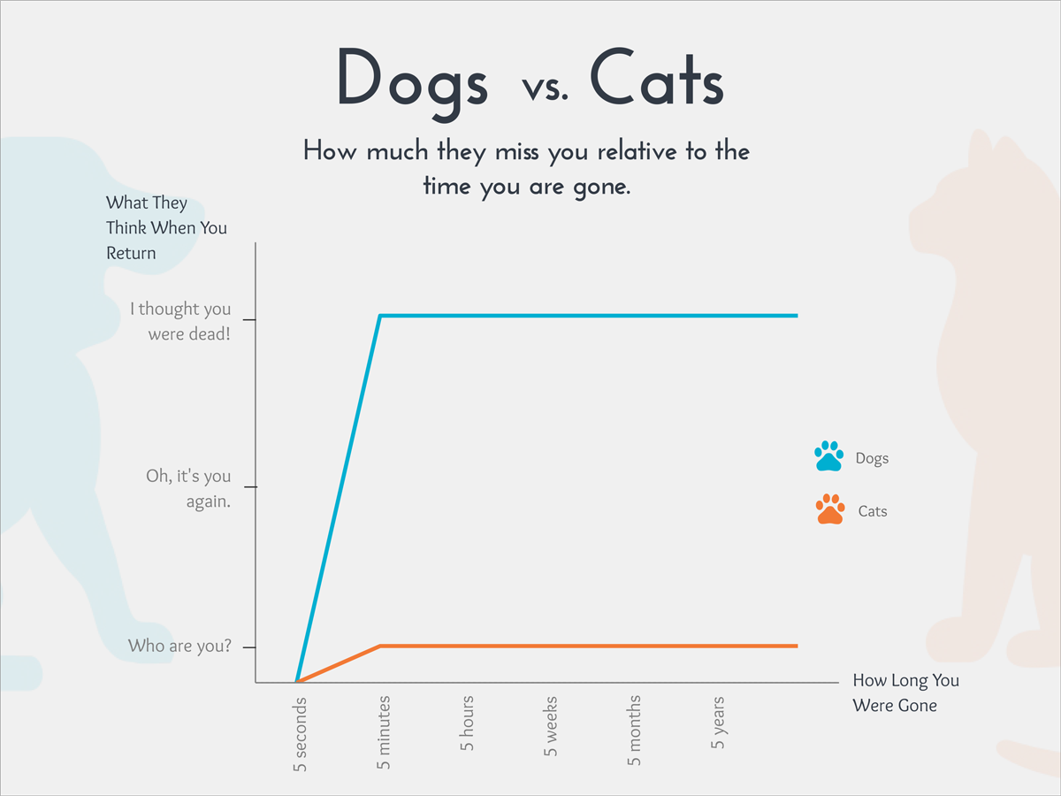

A line graph.



A flow chart.

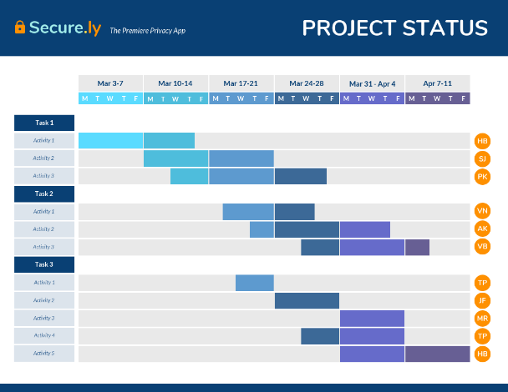

A “Gantt” chart/diagram

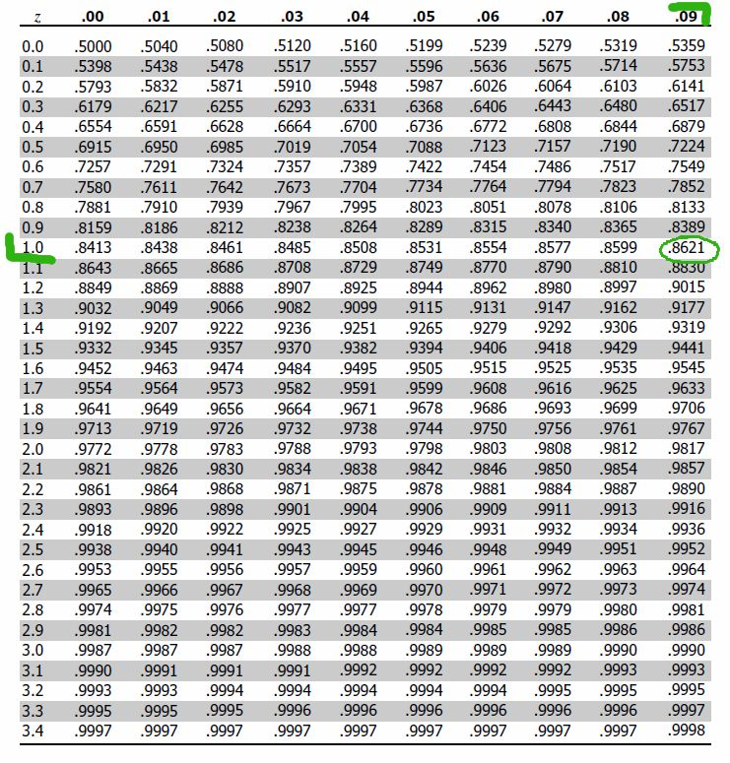

A “area” table

What is the difference between a “bar chart/graph” OR a “Histogram”?

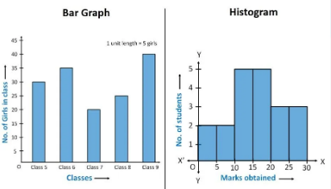

What kind of graph is this?

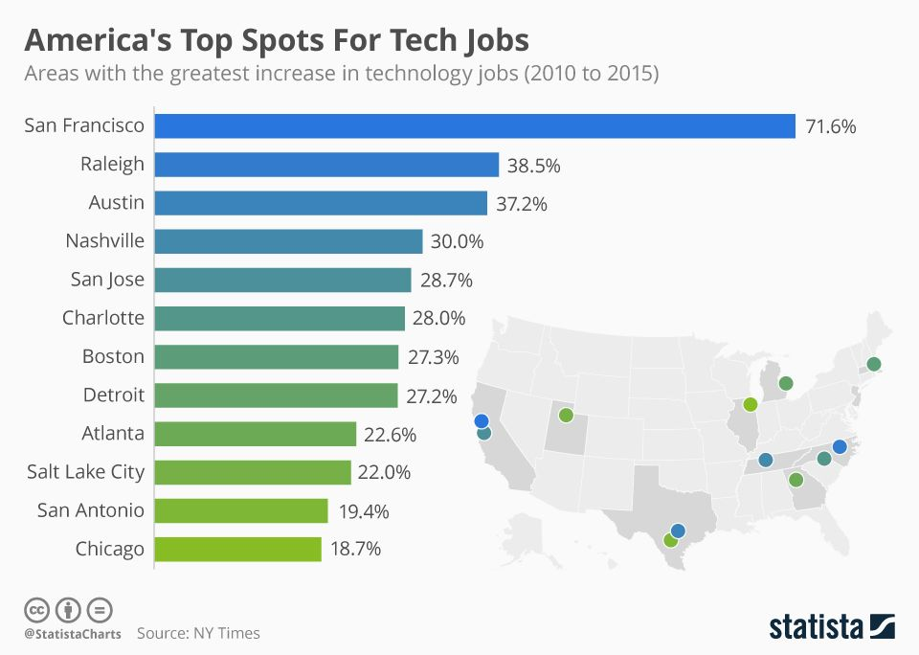

Is a bar chart

Compare: SF – Chicago / Chicago to SF

SF has more jobs than Chicago.

The % of job increase difference between Raleigh and Austin.

Between San Antonio and Charlotte ?

* San Francisco has far/significantly/many/a lot more jobs than Chicago.
* Chicago has a lot/significantly fewer jobs than SF.
* Raleigh’s percentage of job increase is slightly higher than Austin’s.
* The percentage of jobs has increased less in SA.

Question! With fractions, how do you know if you should use a singular or a plural?

*Exemple : 1% des gens n’attrapent pas la maladie.*

1%/One percent of the **people** don’t get the illness/disease. (Plural)

BUT: One third (1/3) of the **population** doesn’t get it. (Singular)

One in three **people** are …. Or one **person** in three is ….

Resume:



Exercise:

Write 4 comparative sentences (use more than, less than, fewer than, higher or lower than)

* Use percentages in at least one of the sentences.
* Write 2 sentences using the superlative.

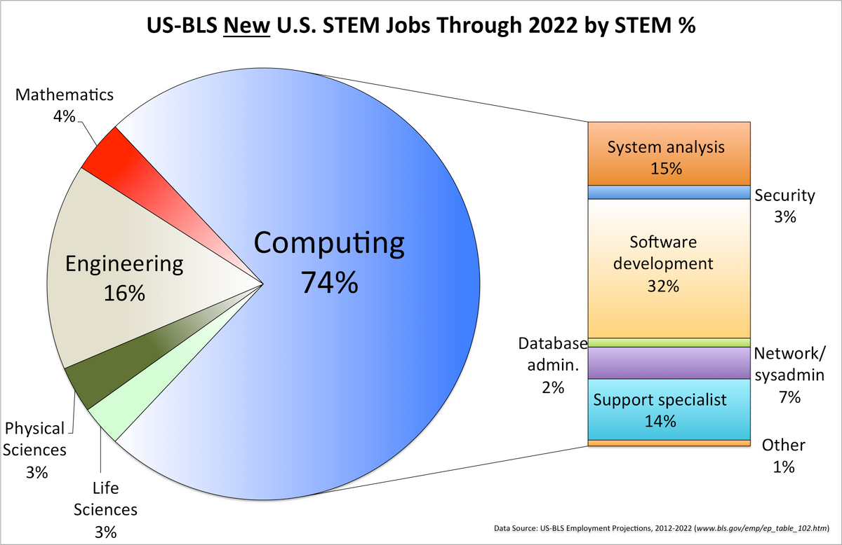

* Mathematics has more than the Physical Sciences.
* Engineering has less than Computing.
* In the computing job he has more Software development than system analysis.
* The Life Sciences as a lot fewer than Computing.
* The best job % is the Computing with 74%.
* The worse job % are the Physical Sciences and the Life Sciences.

Correction:

* There are a lot more computer jobs than mathematics jobs.
* Security field is less interesting than support specialist field.
* Computing has more jobs as more the other stand jobs combined.
* Mathematics are the smallest area in the graph.
* Computing has the highest employment level.